Contents

1. Objective 1

2. Requirements 1

2.1. Teacher 1

2.2. Student 1

2.3. Software Requirement to run this project 1

3. Flow Chart of the application 2

4. Console Application 2

4.1. Architecture of the application 2

4.1.1. Packages and classes 2

5. GUI Application using JAVAFX 4

5.1. Architecture of the Application 4

5.1.1. StartMenuApp 4

5.1. UML CLASS DIAGRAM 4

# Objective

This project will provide a common platform for students and teachers. The teacher can create Quiz and student can take quiz and can see the result.

# Requirements

## Teacher

They can create, search, update and delete quizzes after getting logged in.

They can create, search, update and delete questions for each quiz after getting logged in.

They can enter subjects, difficulties and topics with its options (type of question) and answer at the time of creating quiz.

## Student

They can search quiz according to their topics.

They can make exam according to the id of quiz.

After completing all questions, result will be displayed Automatically.

## Software Requirement to run this project

You need to install an IDE Eclipse.

You also need Java 11.

Finally you need the h2 SQL JDBC.

# Flow Chart of the application

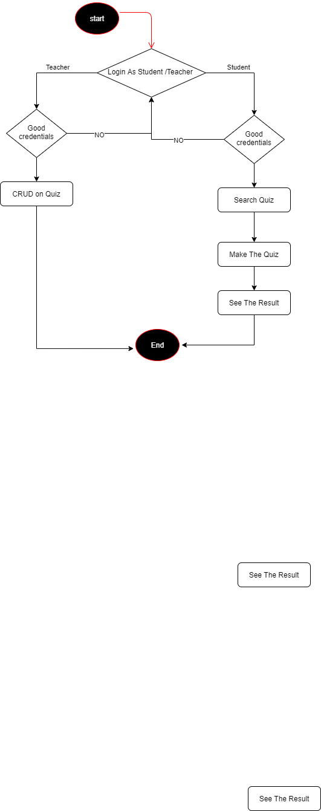

# Console Application

## Architecture of the application

### Packages and classes

All the package are group in one module : fr.epita.quizmanager

#### fr.epita.quizmanager.datamodel

Here we have all the classes modelling our project:

* Question
* MCQQuestion
* OPENQuestion
* MCQChoice
* Student
* Teacher

#### fr.epita.quizmanager.exception

Here we are handling all the exception:

* CreateFailedException
* DeleteFailedException
* UpdateFailedException

#### fr.epita.quizmanager.launcher

In this package we have the main class which launch the application menu

* StartMenu

#### fr.epita.quizmanager.launcher.menu

In this package we have the different menu classes

* TeacherMenu
* StudentMenu

#### fr.epita.quizmanager.services

Finally for our services we create a package. That is:

* Configuration of the Connection to the db
* The Login Menu
* Teacher Menu Platform
* Student Menu Platform

#### fr.epita.quizmanager.services.dao

Here we have all the Classes which allows the access to the database:

* QuestionDAO
* StudentDAO
* TeacherDAO
* TopicDAO
* OpenQuestionDAO

# GUI Application using JAVAFX

## Architecture of the Application

First we need to make package of the console application available (by exporting them in the module above ) then In addition to classes of console application we implemented:

### StartMenuApp

It is the launcher of the javaFXapp

## UML CLASS DIAGRAM

